AED Wall Cabinet

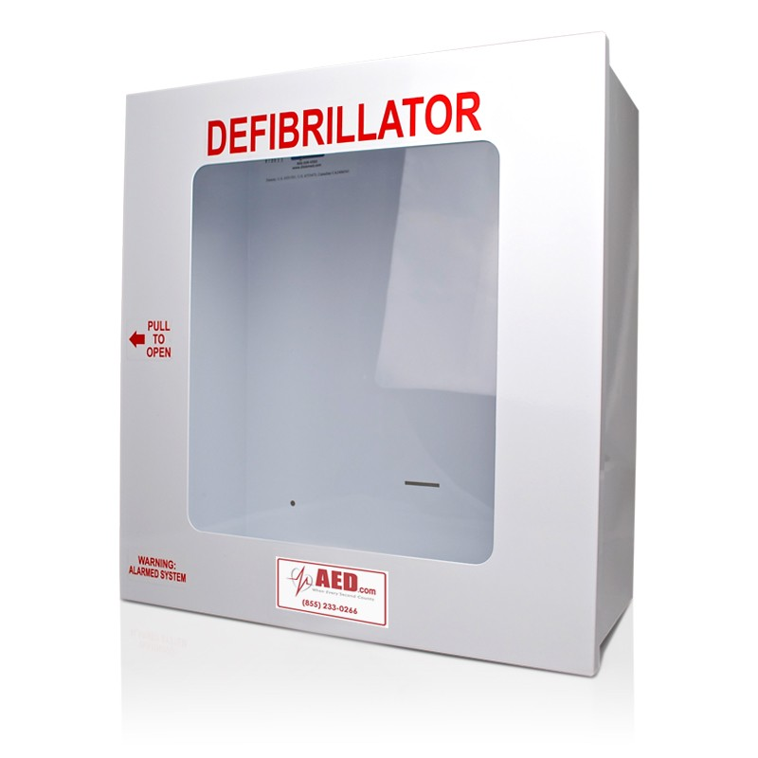

• KEYLESS ALARM can be controlled from the outside or inside of the cabinet
• Alarm is ultra-small so it doesn’t waste cabinet space yet produces 90 decibels of sound
• Molded side handle is flush, preventing accidental openings and damage
• Magnetic door latch provides solid closure and trouble-free opening
• Entire cabinet front swings open to allow for easy access
• Clear impact resistant acrylic window (9 ¼” W x 10 5/8” H)
• Powder coat finish provides durable protection
• 20-gauge steel welded throughout (20% thicker than 22 gauge)
• Height: 15”, Width: 14”, Depth: 6 ¾”, Weight: 10lbs
• Shipped fully assembled in protective foam packaging
• One year limited warranty

*Accommodates EVERY major AED on the market

Editor’s Note (not for website):
Source: https://www.aed.com/aedcom-aed-wall-cabinet.html#Description

